Weight Lifting and Immune Response

# Problem

As a part of the mating ritual of the black wheatear, the male puts on an exaggerated display of strength by carrying many stones into caves. These types of displays are often a signal to the females of the fitness and health of the male. Various tests were conducted to determine if there is a relationship between male black wheatear health and the weight of the stones carried. Here we examine the relationship between the weight of stones carried and the male T-cell response. Stronger T-cell responses are expected from healthier black wheatears.

# Assumptions and Method

A linear regression line of the T-cell response in relation to the mean mass of stones carried, with

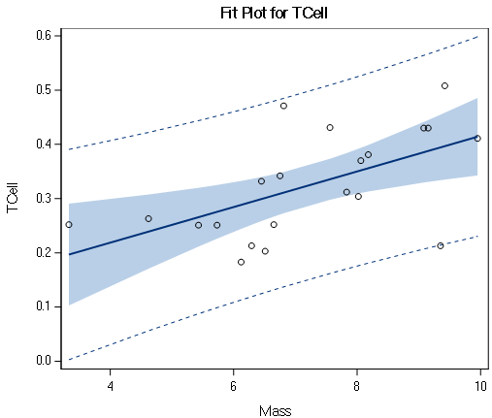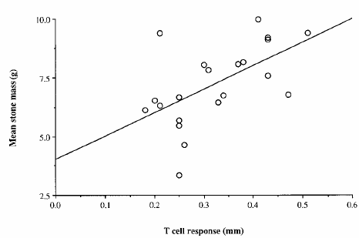

95% confidence limits shown by the blue shaded area and 95% prediction limits shows by the dashed lines, demonstrates the expected positive relationship. On the right is the scatterplot with the T-cells on the x-axis. The assumptions needed for this model are:

1. For each value of the explanatory variable, mass, the response variable is normally distributed.
2. The means of those distributions fall on a linear function of mass.
3. Those distributions have equal standard deviations.
4. Independence.

To assess these assumptions graphical tools are used. The scatterplot above and qq plot below do not show any problem with a linearity assumption. A scatterplot of the residuals and a histogram of residuals appear to show that the response variable is normally distributed for each value of the explanatory variable and that the spread of the residuals does not appear to vary.

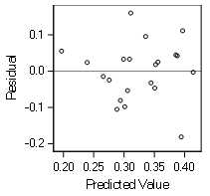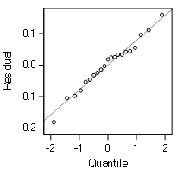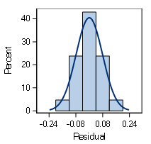

The assumptions for this model all appear to be met with no transformations necessary.

# Results

The regression equation shown above is:

$$Tcell Response=0.03282\left(Mass\right)+0.0875$$

An increase of 1g mean stone mass predicts a 0.3282 increase in T-cell response with 0g mean mass predicting a 0.0875 T-cell response.

| **Parameter Estimates** | | | | | | | |
| --- | --- | --- | --- | --- | --- | --- | --- |
| **Variable** | **DF** | **Parameter Estimate** | **Standard Error** | **t Value** | **Pr > |t|** | **95% Confidence Limits** | |
| **Intercept** | 1 | 0.08750 | 0.07868 | 1.11 | 0.2800 | -0.07717 | 0.25217 |
| **Mass** | 1 | 0.03282 | 0.01064 | 3.08 | 0.0061 | 0.01055 | 0.05509 |

To test these parameters, we will test the hypotheses that they are zero. $H_{0β0}=0, H_{0β1}=0$. The t-statistics and p-values for both the intercept and the slope are given in the table above. The slope is significantly different from 0 with a p-value of 0.0061 so we can reject that $H_{0β1}=0.$ The intercept is not significantly different than 0, therefore we cannot reject $H_{0β0}=0$. We can be confident that there is a positive relationship between mean mass and t-cell response but we cannot say definitively that the intercept is not zero.